(Formerly known as Medical Center Village) | 4701 Chrysler  Detroit, MI 48201  Phone: (313) 831-1725  Fax: (313) 831-4670  2-Bedroom / 1 Bath  Apartment  Approx. 800-825 sq. ft.
M U L T I M I L L I O N D O L L A R R E N O V A T I O N S I N P R O C E S S ! !
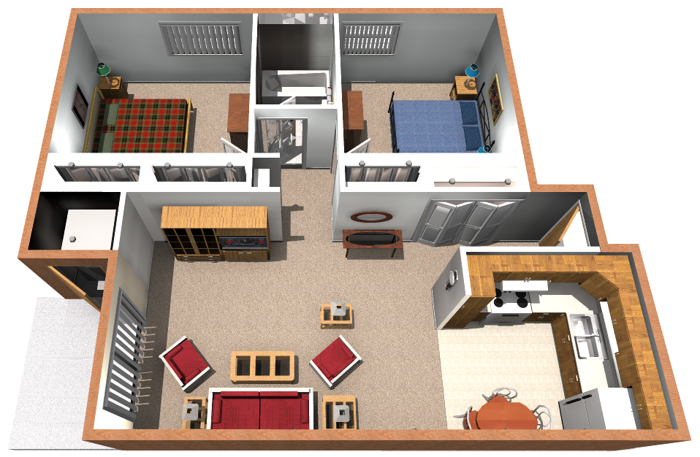
Income Guidelines & Rental Rates (effective 4/1/11)
2 Bedroom Apartment
1 Person |  |  | 2 People |  |  | 3 People |  |  | 4 People
Min. Inc. | Max. Inc. | Rent | Min. Inc. | Max. Inc. | Rent | Min. Inc. | Max. Inc. | Rent | Min. Inc. | Max. Inc. | Rent
$17,900 | $19,000 | $499 | $17,900 | $19,500 | $499 | $17,900 | $21,000 | $499 | $17,900 | $21,000 | $499
$19,000 | $24,000 | $549 | $19,500 | $27,000 | $549 | $21,000 | $30,000 | $549 | $21,000 | $30,000 | $549
$24,000 | $29,340 | $599 | $27,000 | $33,540 | $599 | $30,000 | $37,740 | $599 | $30,000 | $41,880 | $599
Equal Housing Opportunity | Rental rates are subject to change. Artist’s rendering above is based on current development concepts are subject to change without notice.

