(Formerly known as Medical Center Village) | 4701 Chrysler  Detroit, MI 48201  Phone: (313) 831-1725  Fax: (313) 831-4670  3-Bedroom / 1.5 Bath  Townhome  Approx. 1025 sq. ft.
M U L T I M I L L I O N D O L L A R R E N O V A T I O N S I N P R O C E S S ! ! 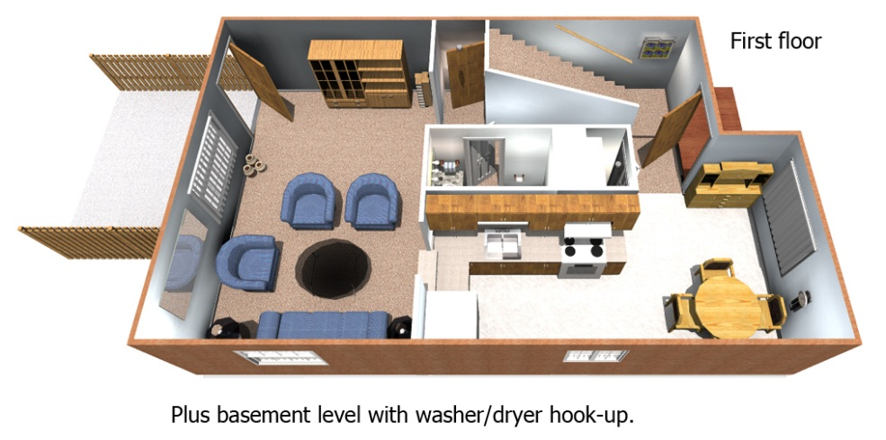
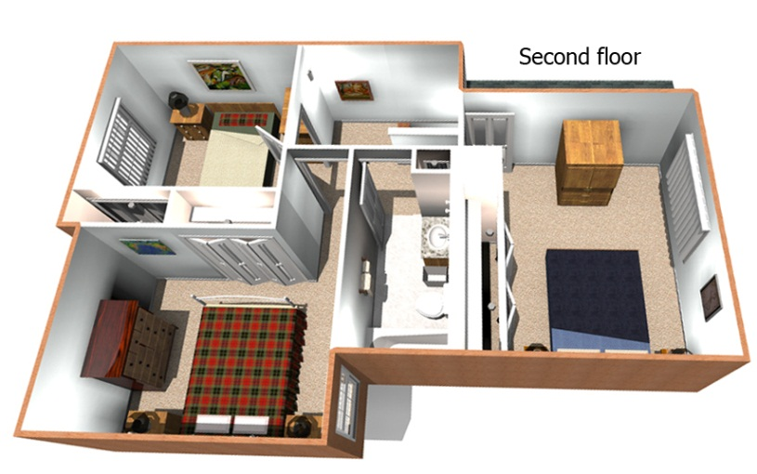
Income Guidelines & Rental Rates (effective 4/1/11)
3 Bedroom Townhome
3 People |  |  | 4 People |  |  | 5 People |  |  | 6 People
Min. Inc. | Max. Inc. | Rent | Min. Inc. | Max. Inc. | Rent | Min. Inc. | Max. Inc. | Rent | Min. Inc. | Max. Inc. | Rent
$25,000 | $27,000 | $699 | $25,000 | $27,000 | $699 | $25,000 | $28,000 | $699 | $25,000 | $28,000 | $699
$27,000 | $30,000 | $759 | $27,000 | $32,000 | $759 | $28,000 | $34,000 | $759 | $28,000 | $34,000 | $759
$30,000 | $37,740 | $798 | $32,000 | $41,880 | $798 | $34,000 | $45,240 | $798 | $34,000 | $48,600 | $798
Equal Housing Opportunity | Rental rates are subject to change. Artist’s rendering above is based on current development concepts are subject to change without notice.

